**Highlights from the NYC School Survey**

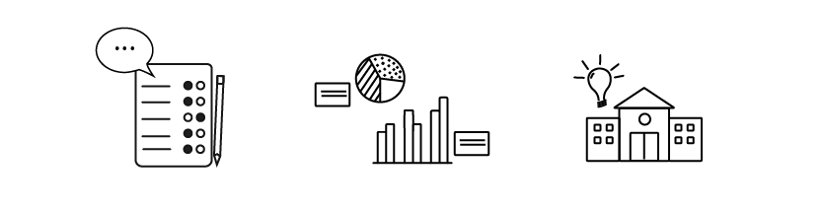

**What is the NYC School Survey?**

Each year, all families, teachers, and students in grades 6-12 take the NYC School Survey to share feedback about their schools. The NYC School Survey is one of the nation’s largest education surveys. Survey feedback can help improve your child’s learning environment.

**Who in our school did we hear from this year?**

* XX of students
* XX of parents/guardians
* XX of teachers

**What are we proud of? Where can we improve?**

[Review your 2025 NYC School Survey results and insert examples of which results stood out to you as a school leader. For example: 85% of parents/guardians agreed or strongly agreed that teachers work closely with them to meet their child's needs. Also, insert examples of which results you have identified to help guide decision making at your school. For example: 62% parents/guardians agreed that they feel well-informed by the communications they receive from their school.]

**How does your feedback help our school?**

To better align with our school mission/goals, based on the feedback we received, we... [consider inserting the areas you identified as indicating program strengths. What is your school or program doing that is leading to positive feedback in these areas? What are issues or areas the group would like to prioritize as needing additional focus and/or attention?]

**How are Results Used at the Citywide Level?**

Survey data guides Citywide professional development initiatives and outreach, such as Bullying Prevention Trainings for schools that score relatively low on the Preventing Bullying measure. Results appear in the [School Quality Snapshot](https://tools.nycenet.edu/snapshot/2024/?utm_source=schools.nyc.gov&utm_medium=Public_Page&utm_campaign=SQR_Public_Page.) to help families evaluate and select appropriate schools for their student(s). The results inform citywide program evaluations and research to ensure students receive high-quality supports and services. Additionally, survey findings are included in the [Mayor's Management Report](https://dmmr.nyc.gov/), a legally mandated document that demonstrates how effectively city agencies are serving the public. NYC School Survey results are publicly available and are used in many ways by Community-based organizations, Universities, and beyond.

**Explore your results:**

Visit the link below to view your school’s NYC School Survey results. You can also visit NYCschoolsurvey.org and click on “survey results page” in the Frequently Asked Questions section.

**<https://secure.panoramaed.com/nycdoe/understand?auth_token=NeMqBRG7xyKtyeqmK_Nd>**