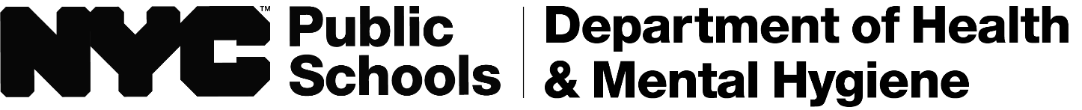

Dear Parent or Guardian,

Your child will receive a vision screening on **____________________** , by the DOHMH Vision Screening Team.

An eye doctor may not be available at school on this day to conduct a full exam. However, your child will be able to select a frame suitable for them if they fail the vision screening test(s). The eyeglasses are free and provided by the program. If a doctor is available, a Passive Consent Form will be sent by the school prior to the above date(s).

If your child fails the screening and a doctor is not available, we will provide you with the Eye Report and Recommendations Form (E12s) and a handout with more information about vision issues. For your child to receive these free eyeglasses, you must have your eye doctor complete and return the E12s form.

Thank you for your cooperation.

Sincerely,

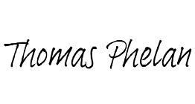Thomas Phelan, Director

School Health Vision Programs

May 2024