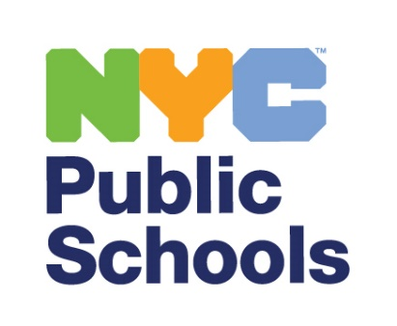

[INSERT DATE]

Dear Parent or Guardian:

New York City Public Schools (NYCPS) believes that our schools become stronger when we listen to our students. This year, students will be invited to participate in the Panorama Education Student Perception Survey, a research-based, confidential student survey used across the country to provide teachers with students’ feedback about their classroom experiences.

Students in grades 6-12 will be invited to participate in the 2024-25 Student Perception Survey. The survey can be completed in 30 minutes or less. The survey administration window is from December 9 through January 17, 2025 and schools will determine when is best to administer.

Questions on the survey ask how your child is experiencing their classes, such as how supported your child feels by their teacher, and whether they find lessons engaging. If you would like to learn more, please visit [www.StudentPerceptionSurvey.nyc](http://www.studentperceptionsurvey.nyc/) where you can read about the 2024-25 Student Perception Survey or contact your school.

All student survey responses are anonymous, and they are kept completely confidential, which means no one in the school will know how your child responded. Students are not asked to provide their names or ID numbers on the survey. The reports that teachers receive will not show individual responses from any student, so you and your child can be confident that their survey answers will remain private.

The survey is voluntary. Families can opt out of participating in the survey by contacting their child’s school. Students may opt out of participating in the survey at the time it is administered even if you do not contact your child’s school. Additionally, if students do not feel comfortable answering a particular question, they may skip it and any other question on the survey they do not wish to answer.

Please contact your child’s school if you would like more information or to see a copy of the survey.

Sincerely,

New York City Public Schools

2024-25 Student Perception Survey

Family FAQs

(Frequently Asked Questions)

**Why are students being asked to take a student survey?**

New York City Public Schools (NYCPS) believes students should have the opportunity to share their insights about the teaching practice they experience in their classrooms. Student voice provides valuable information to educators on ways to improve their practice to better meet students’ needs. Additionally, teachers can use the information to focus on specific areas of their practice; that is, the areas where they are doing well and the areas where there is room for improvement. Please note, the Student Perception Survey is not being administered as a part of *Advance*, New York City’s system for teacher development and evaluation. Results from the survey are for formative purposes only.

**Who will take the survey?**

Students in grades 6-12 will be asked to take the survey. Students should be taught by the teacher for at least four weeks prior to survey administration to participate in the survey.

**What types of questions are on the survey?**

The survey will consist of 38 questions and measures students’ perceptions and attitudes about a specific teacher and their classroom. Specifically, students answer questions across six domains: Pedagogical Effectiveness, Classroom Climate, Classroom Rigorous Expectations, Classroom Engagement, Shared and Inclusive Curriculum, and Teacher-Student Relationships. Items on the survey cover topics such as how supported students feel by their teachers and whether they find lessons engaging. There will be 6 optional demographic questions as well. The survey questions can be found on the 2024-25 Student Perception Survey website at [www.StudentPerceptionSurvey.nyc](http://www.studentperceptionsurvey.nyc/).

**Will anyone see** **students’ answers?**

All student survey responses are kept completely confidential. No one will ever track answers back to an individual student, and students are not asked to share their names or ID numbers. Individual student responses will never be shared with teachers.

**Is my child required to take the survey?**

No, parents or guardians may opt their child out of the survey by following the guidelines provided by your child’s school. Students may also opt out of participating in the survey at the time it is administered. Additionally, students may skip any question on the survey they do not wish to answer.

**When will the Student Perception Survey be administered?**

The administration window is from December 9 through January 17, 2025. Schools can determine when is best to administer the survey within that time frame.